

**Introduction**

The rapid growth of digital media has significantly increased the spread of fake news and misinformation, affecting public trust, social stability, and democratic processes. Manual fact-checking methods are slow and ineffective for handling large volumes of real-time online content.

To overcome this challenge, the Fake News Detection and Verification Tool uses Artificial Intelligence and Natural Language Processing to automatically analyze news articles. By employing transformer-based deep learning models and trusted fact-checking APIs, the system accurately detects and verifies misleading information.

This tool offers a fast, scalable, and reliable solution for assessing news authenticity and supporting informed decision-making.

**Project Statement**

**Fake News Detection and Verification Tool:**

The objective of this project is to design and develop an intelligent **Fake News Detection and Verification Tool** that automatically identifies and verifies misleading news content using Artificial Intelligence and Natural Language Processing techniques. The system employs transformer-based deep learning models to classify news as fake or real and integrates trusted fact-checking APIs to validate claims, providing accurate, scalable, and explainable results through a secure web-based platform.

**Key Features**

· Automated fake news detection using AI

· Claim verification with trusted APIs

· Advanced NLP-based text analysis

· Explainable results with confidence scores

· Secure and user-friendly dashboard

**Outcomes**

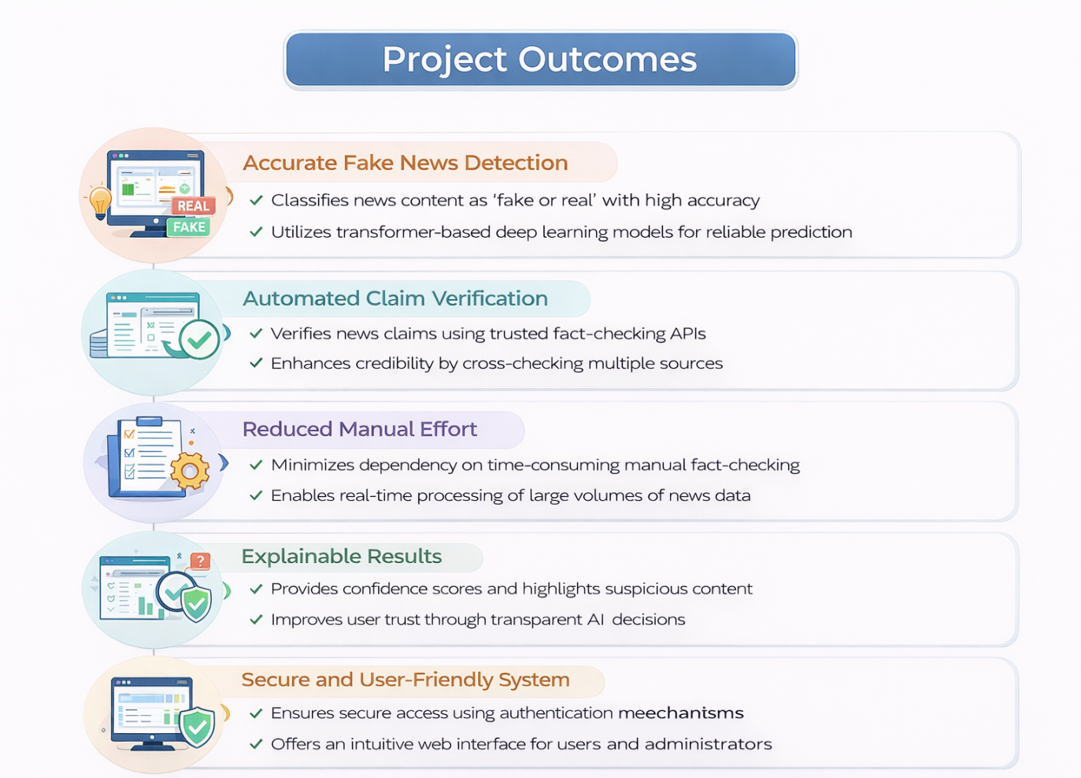

· Accurately classifies news content as fake or real using transformer-based deep learning models.

· Automatically verifies detected claims through integration with trusted fact-checking APIs.

· Reduces reliance on manual fact-checking by enabling real-time analysis of large volumes of news.

· Provides transparent results with confidence scores and highlighted suspicious content.

· Ensures secure and user-friendly access through authentication and an intuitive dashboard.

In the future, the system can be enhanced to support multilingual news and multimedia content analysis. Integration with social media and real-time alerts can provide faster, more reliable fake news detection globally.

**Modules Overview**

**Module 1 — User Authentication & Security**

* **User Registration:** Secure account creation with email/username verification.
* **Login & Access Control:** Authentication using email/username and password with proper validation.
* **Security:** Issue and verify tokens for secure session management and protected route

### ****Module 2 — Input Processing & Preprocessing****

### ****Text Upload / URL Fetch:**** Accept user input via file upload or fetch text content from URLs.

### ****Preprocessing Pipeline:**** Clean and standardize text by removing noise, punctuation, stopwords, and normalizing case.

### ****Optional Enhancements:**** Handling special characters, HTML tag removal, tokenization for downstream NLP tasks.

### ****Module 3 — NLP & Feature Extraction****

### ****Named Entity Recognition (NER):**** Identify and classify entities like names, locations, dates, and organizations in text.

* **Part-of-Speech (POS) Tagging:** Assign grammatical tags (noun, verb, adjective, etc.) to each word for syntactic understanding
* **Lemmatization:** Reduce words to their base or root form to unify different word forms for analysis.
* **Optional Enhancements:** Dependency parsing, n-gram extraction, and custom feature engineering for ML models.

### ****Module 4 — Classification Module****

* **Transformer-Based Fake News Classifier:** Use state-of-the-art transformer models (BERT, RoBERTa, etc.) to classify text as real or fake.
* **Optional Enhancements:** Fine-tune models for domain-specific data and improve accuracy with ensemble methods.
* **Performance Monitoring:** Track model metrics such as accuracy, precision, recall, and F1-score for continuous improvement

### ****Module 5 — Claim Verification****

* **Fact-Checking API Integration:** Verify claims against reliable sources using APIs or knowledge bases.
* **Optional Enhancements:** Cross-reference multiple sources and score claim credibility.
* **Automated Source Ranking:** Prioritize sources based on reliability, trust score, or recency of information.

### ****Module 6 — Explainability & Visualization****

* **Suspicious Text Highlighting:** Visualize parts of the text flagged as potentially misleading or fake.
* **Explainable AI Features:** Provide model reasoning using attention maps, SHAP, or LIME for transparency.
* **Interactive Visualization:** Allow users to explore model predictions and feature contributions for better understanding.

### ****Module 7 — Admin Dashboard****

### ****Manage Sources:**** Add, update, or remove verified sources used for claim verification.

* **Monitor Usage:** Track system activity, user interactions, and model performance metrics.
* **User Management:** Control user roles, permissions, and access levels within the system.

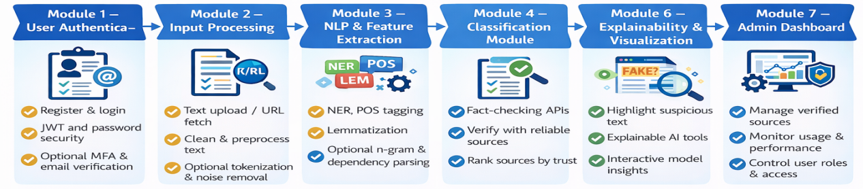

# Architecture Diagram

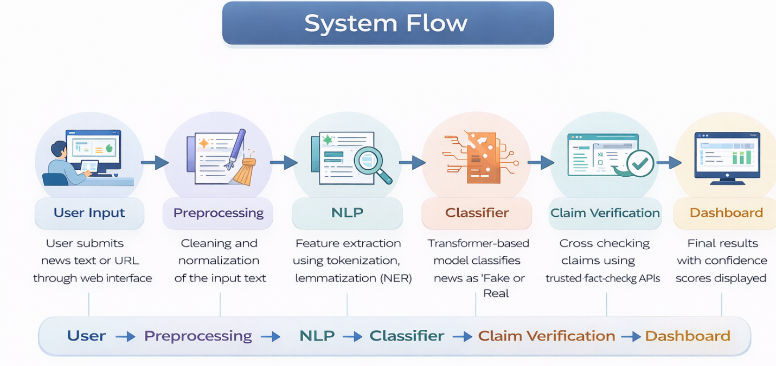

· **User:**  
Users submit news content in the form of text or URLs through a secure web interface.

· **Preprocessing Module:**  
Removes noise such as stopwords, special characters, and punctuation, and normalizes the text for analysis.

· **NLP & Feature Extraction:**  
Performs tokenization, lemmatization, Named Entity Recognition (NER), and POS tagging to extract meaningful linguistic features.

· **Classification Module:**  
Uses transformer-based deep learning models (BERT, RoBERTa, DistilBERT) to classify news as Fake or Real with confidence scores.

· **Claim Verification Module:**  
Cross-checks detected claims using trusted fact-checking APIs to improve prediction reliability.

· **Dashboard & Visualization:**  
Displays results with confidence scores, highlights suspicious content, and provides monitoring features for administrators.

**Database/ Schema Overview**

| **Table Name** | **Columns (PK / FK)** | **Key Fields** |
| --- | --- | --- |
| **Users** | user_id (PK) | username, email, password_hash, role, created_at, updated_at |
| **Articles** | article_id (PK), user_id (FK → Users) | title, url, content, created_at, updated_at |
| **Processed_Text** | processed_id (PK), article_id (FK → Articles) | cleaned_text, tokens |
| **Entities** | entity_id (PK), processed_id (FK → Processed_Text) | entity_name, entity_type, position_start, position_end |
| **Verification_Results** | verification_id (PK), article_id (FK → Articles) | claim_text, source_verified, credibility_score, status, checked_at |

**ER diagram**

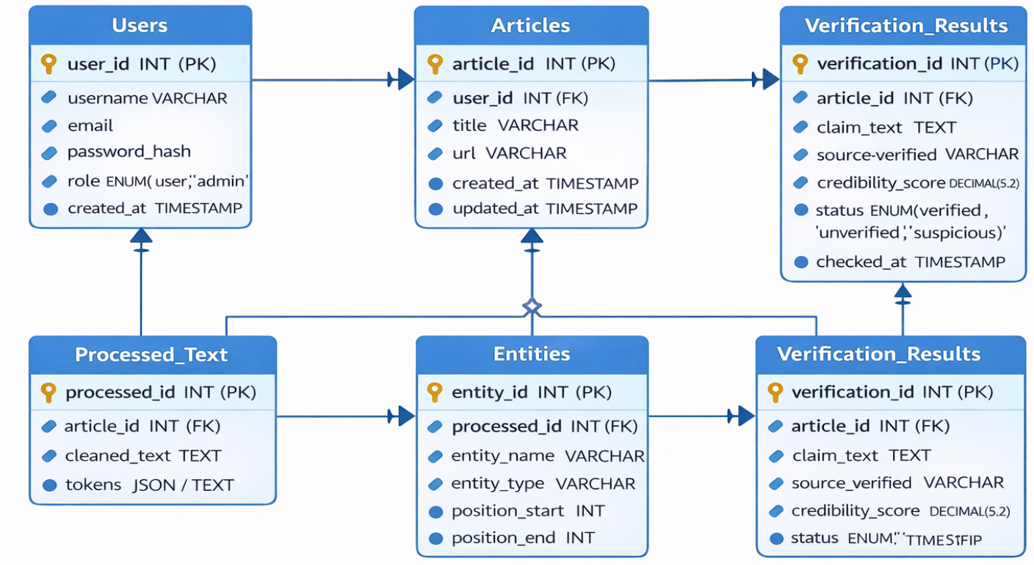

**Conclusion**

* The Fake News Detection and Verification Tool effectively combats misinformation by combining secure user authentication, text input processing, and advanced NLP techniques. Transformer-based models classify news as real or fake, while claim verification cross-checks information against reliable sources for credibility and transparency.
* Explainability features highlight suspicious text and visualize model decisions, building user trust. The admin dashboard monitors usage and sources, while the database stores all relevant data to ensure integrity and scalability.
* Overall, this tool not only automates fake news detection but also supports reliable fact-checking, helping users identify misinformation quickly and make informed decisions, which is crucial in today’s information-driven world.

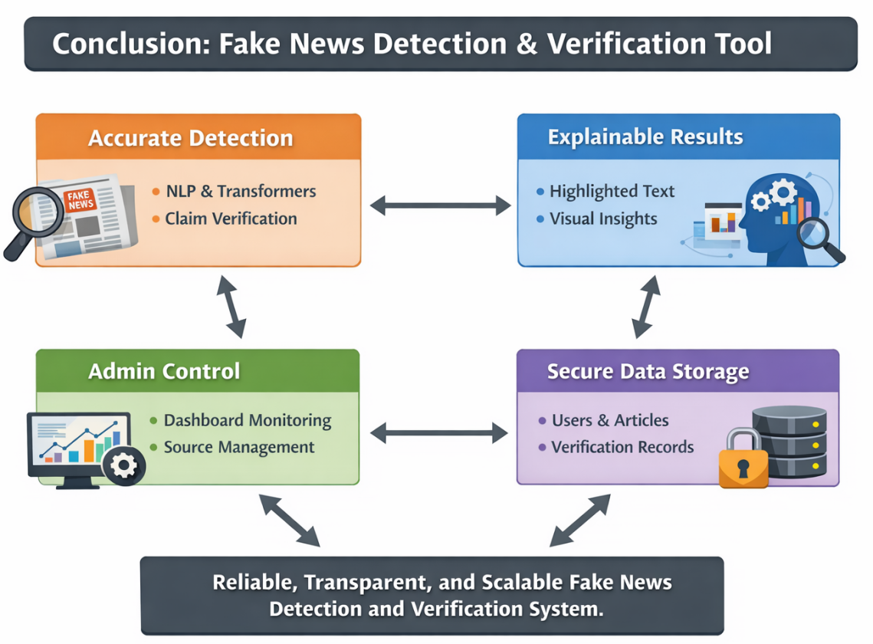

**Future Enhancement**

· **Multilingual Support:** Extend detection and verification to multiple languages.

· **Real-Time Monitoring:** Enable instant verification of trending news articles.

· **Advanced AI Models:** Use ensemble or multimodal AI for higher accuracy.

· **User Feedback Integration:** Allow users to flag suspicious content to improve the model.

· **Mobile Application:** Provide instant access and notifications on mobile devices.

· **Bias & Sentiment Analysis:** Detect biased or emotionally manipulative content alongside fake news.

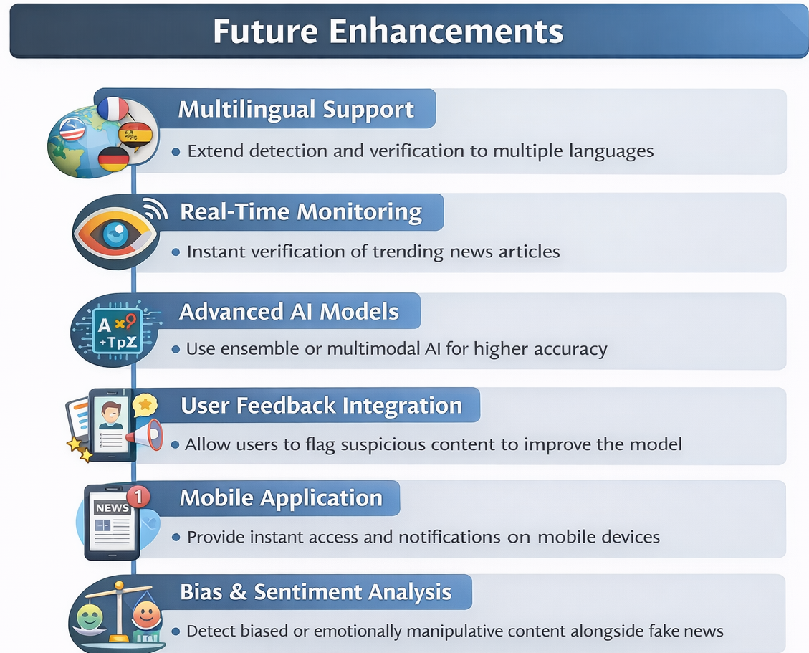

**Sample Code: App.py**

**About.hmtl**

*{% extends "base.html" %}*

*{% block content %}*

*<h2>TruthGuard</h2>*

*<p>AI-based Fake News Detection System.</p>*

*<p>Uses NLP and Machine Learning models.</p>*

*<p>Analyzes news articles and social media content.</p>*

*<p>Classifies news as Reliable, Suspicious, or Fake.</p>*

*<p>Provides confidence score for each analysis.</p>*

*<p>Helps users make informed decisions.</p>*

*{% endblock %}*

**Register.html**

*<form method="POST" action="{{ url_for('register') }}">*

*<label>Full Name</label>*

*<input type="text" name="name" required>*

*<label>Email</label>*

*<input type="email" name="email" required>*

*<label>Password</label>*

*<input type="password" name="password" required>*

*<label>Confirm Password</label>*

*<input type="password" name="confirm_password" required>*

*<label>*

*<input type="checkbox" required> Accept Terms & Privacy Policy*

*</label>*

*<button type="submit">Register</button>*

*</form>*

**Login.html:**

*<form method="POST" action="{{ url_for('login') }}">*

*<label>Email</label>*

*<input type="email" name="email" required>*

*<label>Password</label>*

*<input type="password" name="password" required>*

*<label>*

*<input type="checkbox" name="remember"> Remember Me*

*</label>*

*<button type="submit">Login</button>*

*</form>*

**Profile.html**

*def profile():*

*if request.method == 'POST':*

*if request.form.get('name'):*

*current_user.name = request.form['name']*

*if request.form.get('current_password') == request.form.get('new_password'):*

*current_user.password = generate_password_hash(*

*request.form['new_password']*

*)*

*db.session.commit()*

*return redirect(url_for('profile'))*

*return render_template('profile.html')*

**Dashboard.html**

*<h2>Welcome, {{ user.name }}</h2>*

*<div>*

*<p>Total Analyses: {{ stats.total }}</p>*

*<p>Reliable: {{ stats.reliable }}</p>*

*<p>Suspicious: {{ stats.suspicious }}</p>*

*<p>Fake: {{ stats.fake }}</p>*

*</div>*

*<a href="/analyze">New Analysis</a>*

*<a href="/history">View History</a>*

*<a href="/profile">Profile</a>*

**Admin Dashboard.html**

*<h2>Admin Dashboard</h2>*

*<div>*

*<p>Total Users: {{ stats.total_users }}</p>*

*<p>Total Analyses: {{ stats.total_analyses }}</p>*

*<p>Active Users: {{ stats.active_users }}</p>*

*<p>Average Confidence: {{ avg_confidence }}%</p>*

*</div>*

*<hr>*

*<h4>Classification Summary</h4>*

*<ul>*

*<li>Reliable: {{ stats.classifications.RELIABLE }}</li>*

*<li>Suspicious: {{ stats.classifications.SUSPICIOUS }}</li>*

*<li>Fake: {{ stats.classifications.FAKE }}</li>*

*</ul>*

*<a href="/admin/users">Manage Users</a> |*

*<a href="/admin/analyses">View Analyses</a>*

**Sample OutPut:**





  